# **# Employee Database: Pewlette Hackard**

**#### Data Modeling**

Inspect the CSVs and sketch out an ERD of the tables.

Tool used: [http://www.quickdatabasediagrams.com](<http://www.quickdatabasediagrams.com>)

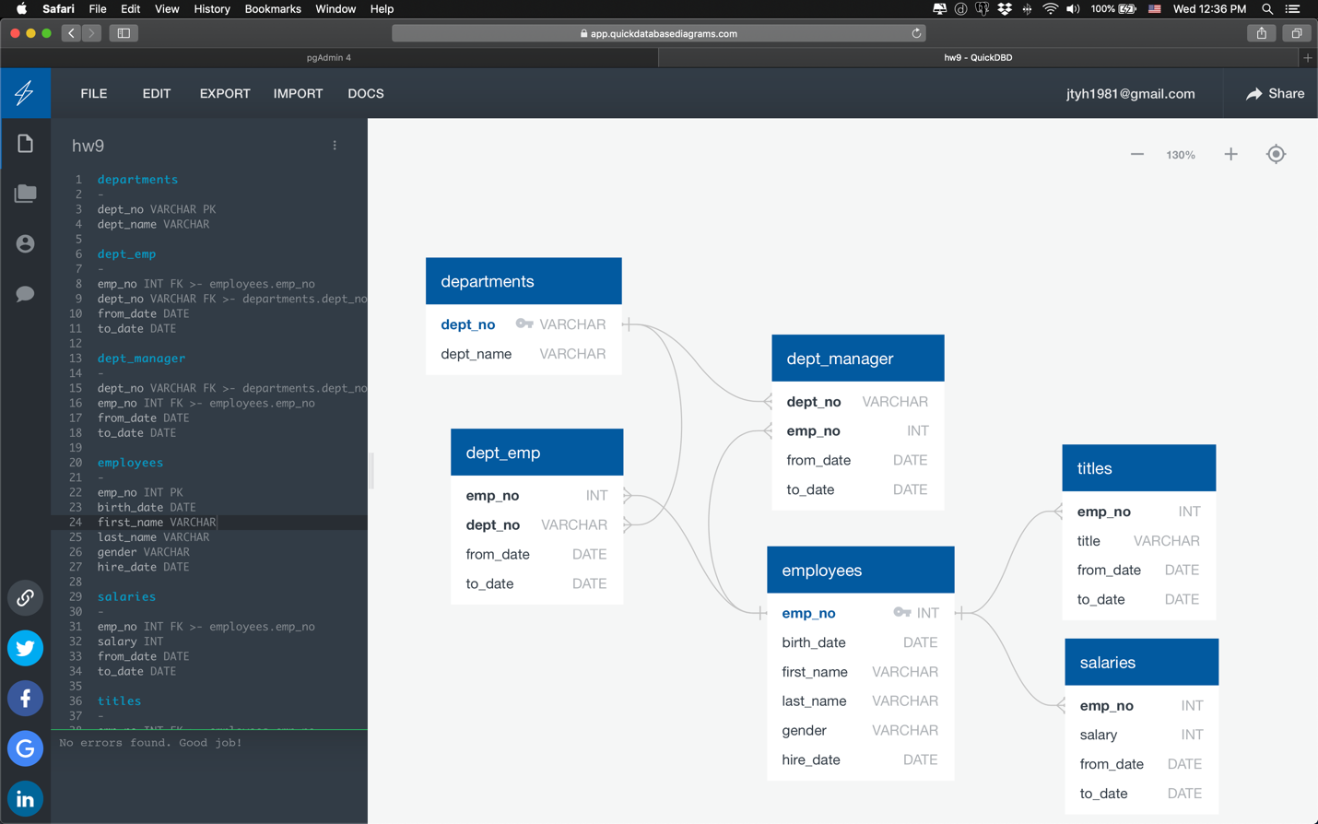

Figure Screenshot of ERD for the tables

**#### Data Engineering**

* Create a table schema for each of the six CSV files. Specifying data types, primary keys, foreign keys, and other constraints.

* Import CSV file into the corresponding SQL table.

**#### Data Analysis**

1. List the following details of each employee: employee number, last name, first name, gender, and salary.

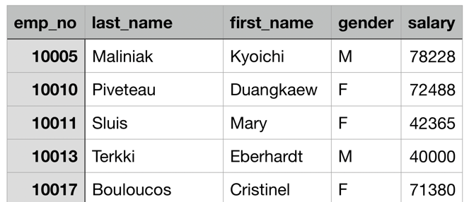

Figure Screenshot of q1 Output

2. List employees who were hired in 1986.

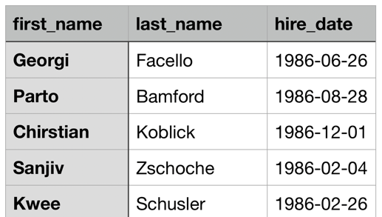

Figure Screenshot of q2 Output

3. List the manager of each department with the following information: department number, department name, the manager's employee number, last name, first name, and start and end employment dates.

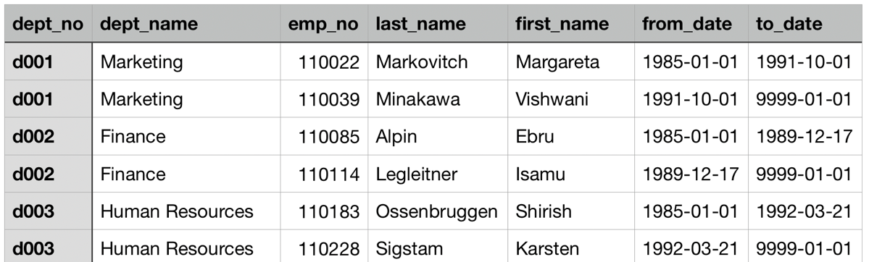

Figure Screenshot of q3 Output

4. List the department of each employee with the following information: employee number, last name, first name, and department name.

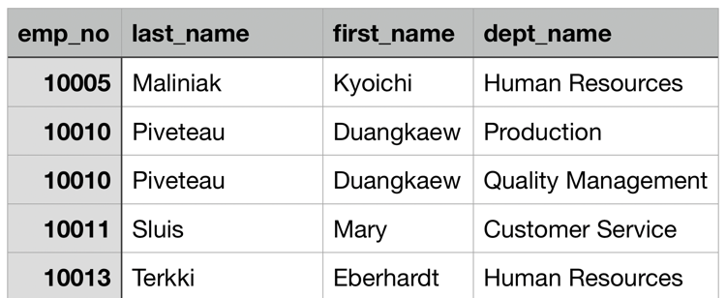

Figure Screenshot of q4 Output

5. List all employees whose first name is "Hercules" and last names begin with "B."

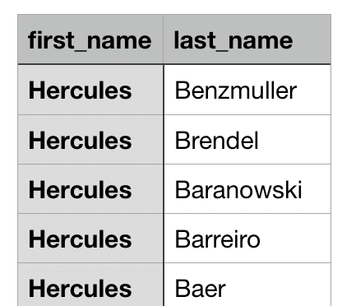

Figure Screenshot of q5 Output

6. List all employees in the Sales department, including their employee number, last name, first name, and department name.

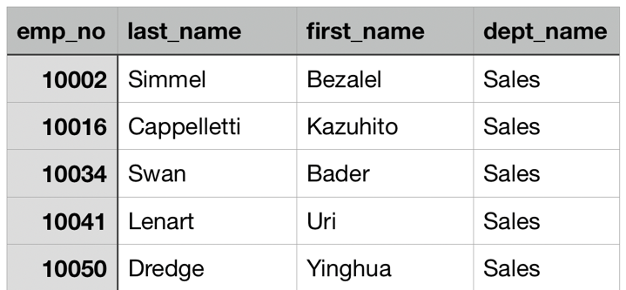

Figure Screenshot of q6 Output

7. List all employees in the Sales and Development departments, including their employee number, last name, first name, and department name.

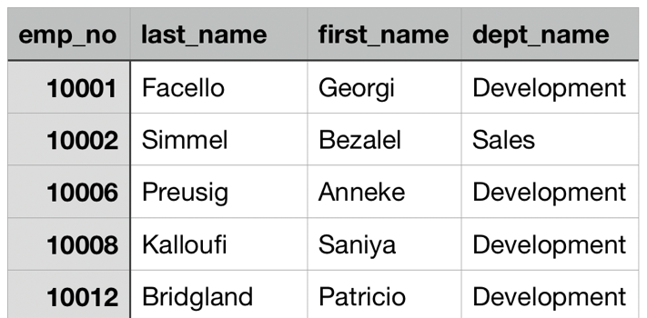

Figure Screenshot of q7 Output

8. In descending order, list the frequency count of employee last names, i.e., how many employees share each last name.

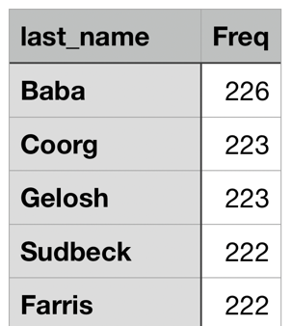

Figure Screenshot of q8 Output

## Bonus (Optional)

1. Import the SQL database into Pandas.

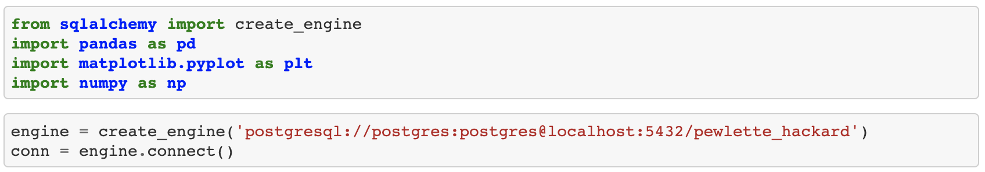

2. Create a bar chart of average salary by title.

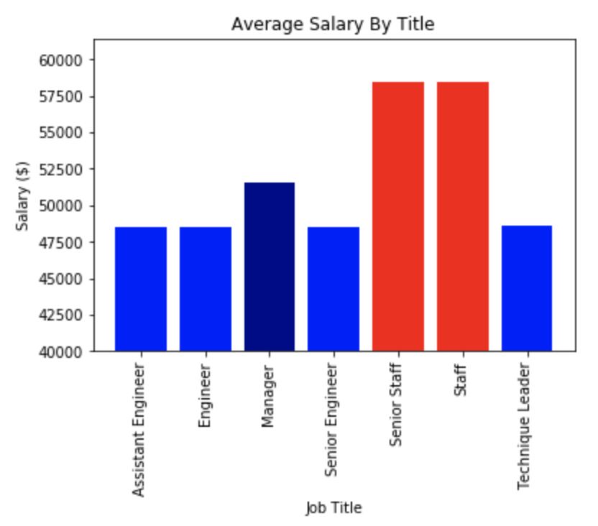

Reference:

Github repository link:

*https://github.com/Jason-T-BCS/hw9_SQL.git*

or

*git@github.com:Jason-T-BCS/hw9_SQL.git*